Software Quality Engineering
PBL

Submitted by:
Ahmad Zia
M. Abdullah
SAP ID: 54635 & 47618

BSSE 6

Project Title:
Tour guide (Mobile App)

- Manual Testing:

- Test Cases
Test Case ID | Module | Test Objective | Preconditions | Test Data | Test Steps | Expected Result | Actual Result | Status
TC-01 | Login | Verify customer login with valid credentials | Customer account exists | Email: ali@gmail.com Password: 123456 | 1. Open Login Screen 2. Enter valid email 3. Enter valid password 4. Click Login | Customer successfully logs in and Packages screen opens | As Expected | Pass
TC-02 | Login | Verify login with invalid email | Customer account exists | Email: ali@gmail.com Password: abc123 | 1. Open Login Screen 2. Enter valid email 3. Enter wrong password 4. Click Login | Error message displayed for invalid credentials | As Expected | Pass
TC-03 | Registration | Verify new customer registration | User not already registered | Name, Email, Phone, Password | 1. Click Create Account 2. Fill all fields 3. Click Register | Account created successfully | As Expected | Pass
TC-04 | Registration | Verify duplicate email validation | Email already registered | Existing Email | 1. Open Registration 2. Enter existing email 3. Submit form | "Email already exists" message displayed | As Expected | Pass
TC-05 | Package Booking | Verify package can be added to cart | Customer logged in | Valid Package | 1. Open Packages Screen 2. Select package 3. Click Book Now | Package added to cart successfully | As Expected | Pass
TC-06 | Cart | Verify total price calculation | Cart contains packages | Multiple packages | 1. Open Cart 2. View selected packages | Total price calculated correctly | As Expected | Pass
TC-07 | Checkout | Verify successful checkout | Cart contains packages | Valid booking | 1. Open Cart 2. Click Checkout | Checkout successful message displayed and cart emptied | As Expected | Pass
TC-08 | Query Form | Verify query submission with valid information | Customer logged in | Valid Name, Email, Query | 1. Open Query Form 2. Fill all fields 3. Submit | Query submitted successfully | As Expected | Pass
TC-09 | Query Form | Verify invalid email validation | Customer logged in | Email: ali@gmails | 1. Open Query Form 2. Enter invalid email 3. Submit | Email validation error displayed | As Expected | Pass
TC-10 | Rating | Verify customer can submit rating | Customer logged in | 5-Star Rating | 1. Open Rating Screen 2. Select 5 stars 3. Submit | Rating saved successfully | As Expected | Pass
TC-11 | Gallery Upload | Verify image upload request | Customer logged in | Valid Image | 1. Open Upload Screen 2. Select image 3. Upload | Waiting for admin approval message displayed | As Expected | Pass
TC-12 | Admin Package CRUD | Verify admin can add package | Admin logged in | Name, Description, Duration, Price, Seats | 1. Open Dashboard 2. Click Add Package 3. Fill details 4. Save | Package added successfully | As Expected | Pass
TC-13 | Admin Query Management | Verify admin updates query status | Admin logged in | Query Status = Resolved | 1. Open Queries 2. Select query 3. Change status | Query status updated successfully | As Expected | Pass
TC-14 | Admin Photo Approval | Verify admin approves uploaded image | Admin logged in | Pending Image | 1. Open Photo Requests 2. Click Approve | Image appears in Gallery | As Expected | Pass
TC-15 | Settings | Verify dark mode toggle functionality | User logged in | Toggle ON | 1. Open Settings 2. Enable Dark Mode | Dark theme applied successfully | As Expected | Pass
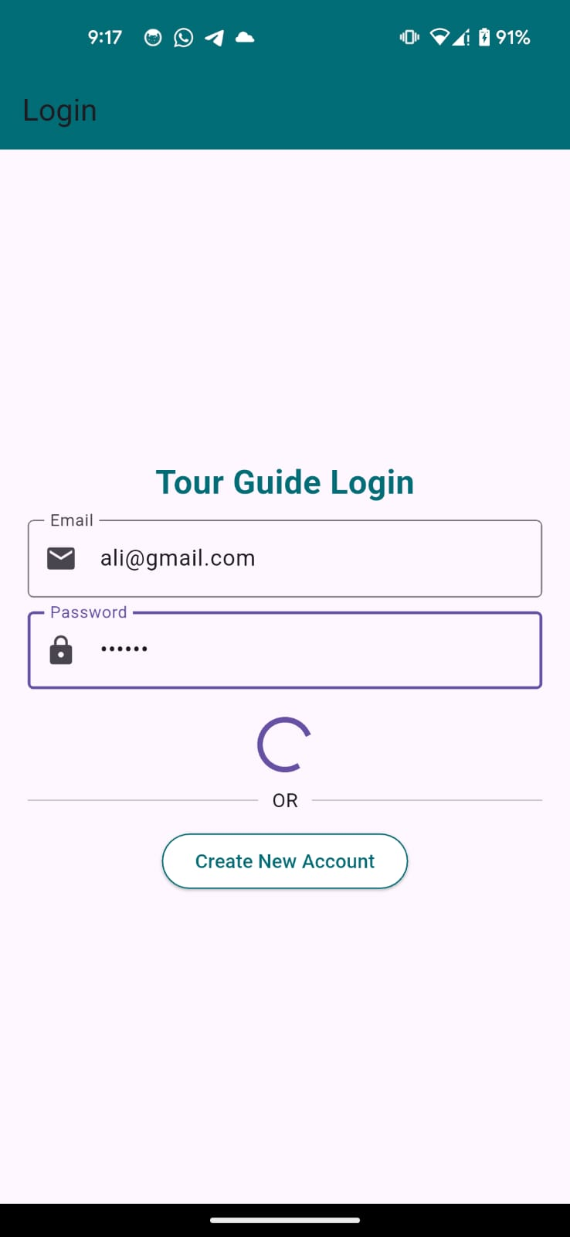
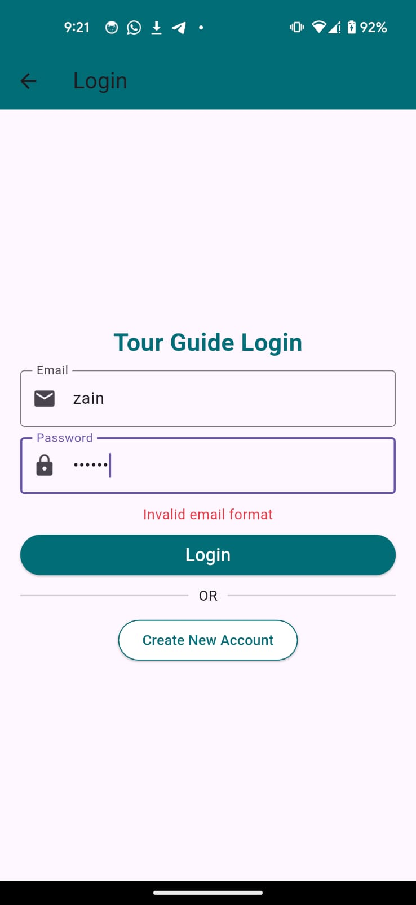
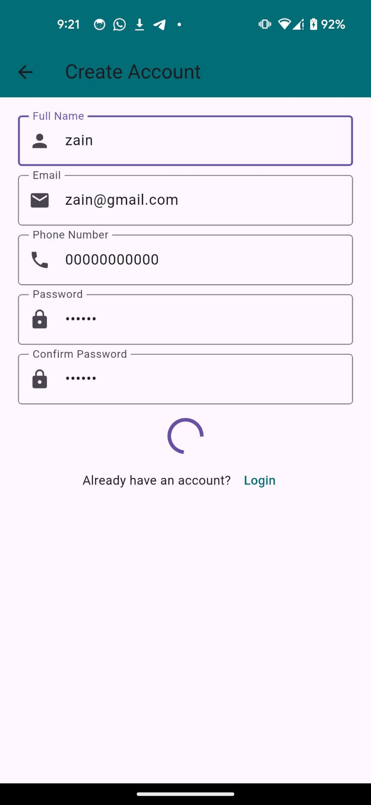
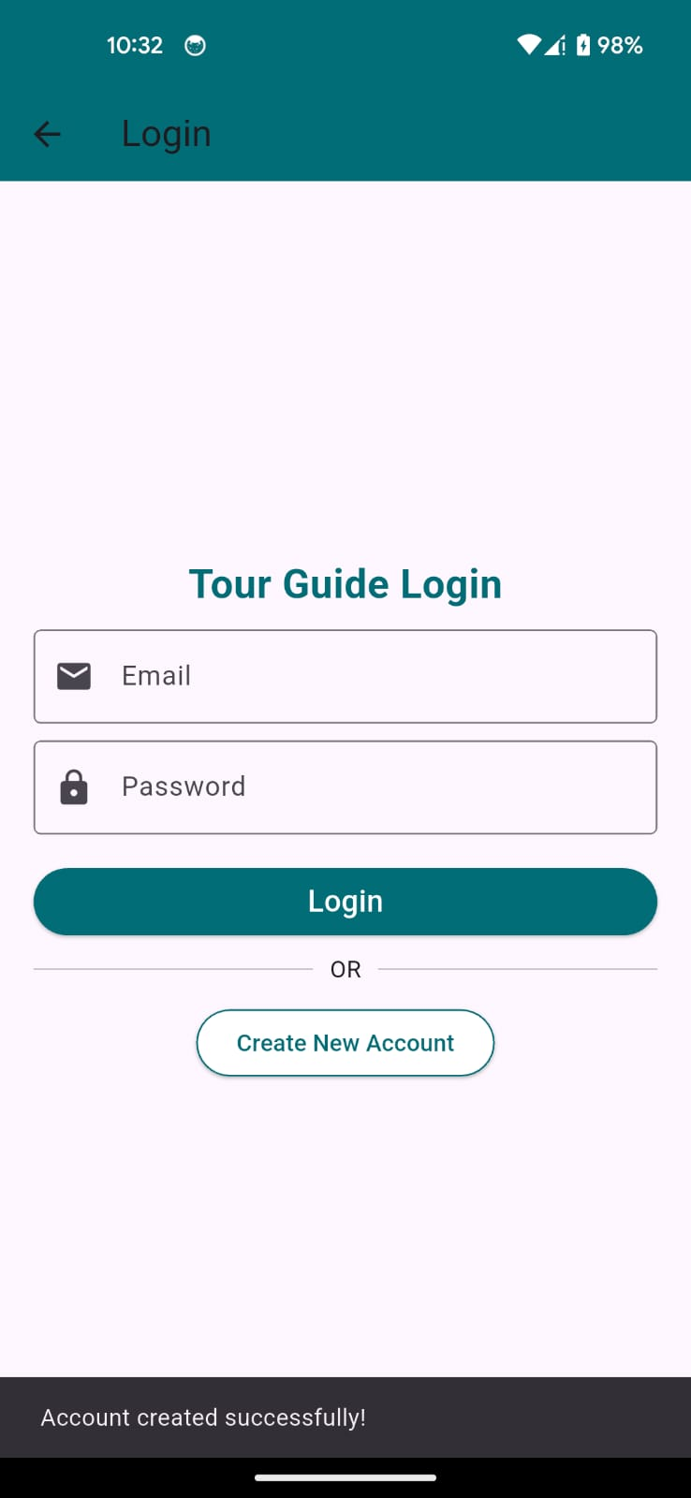
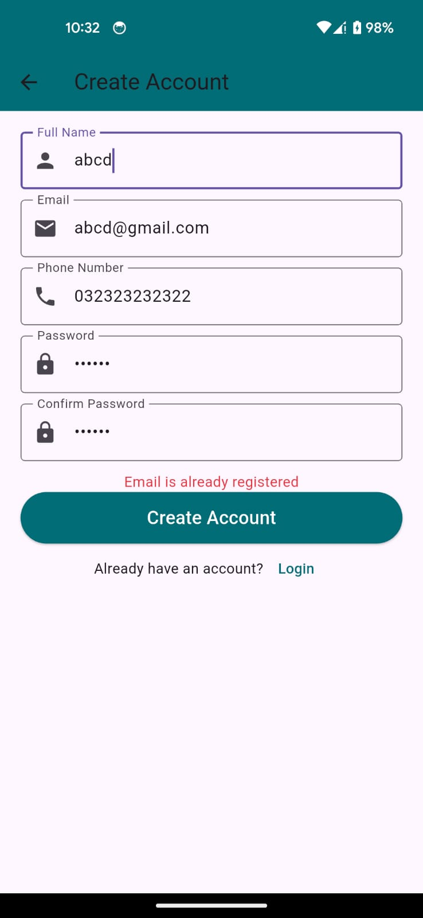

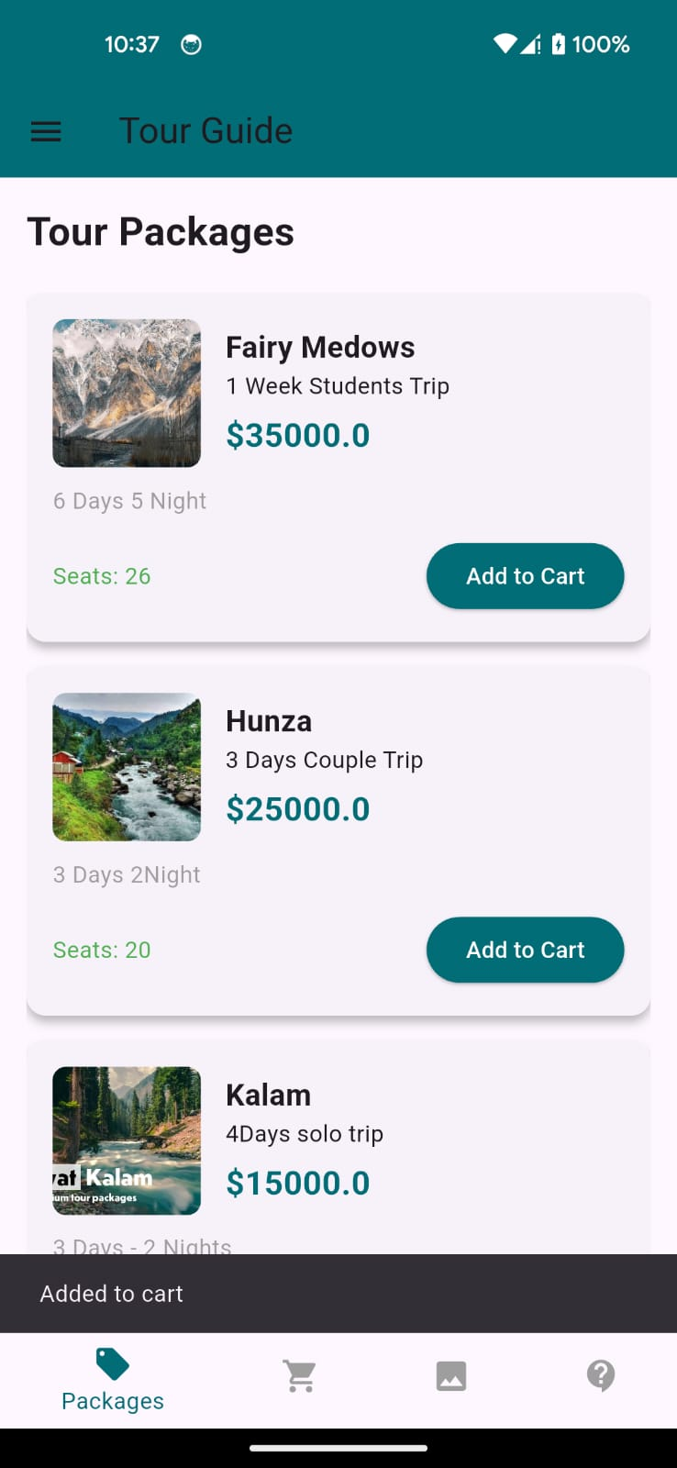
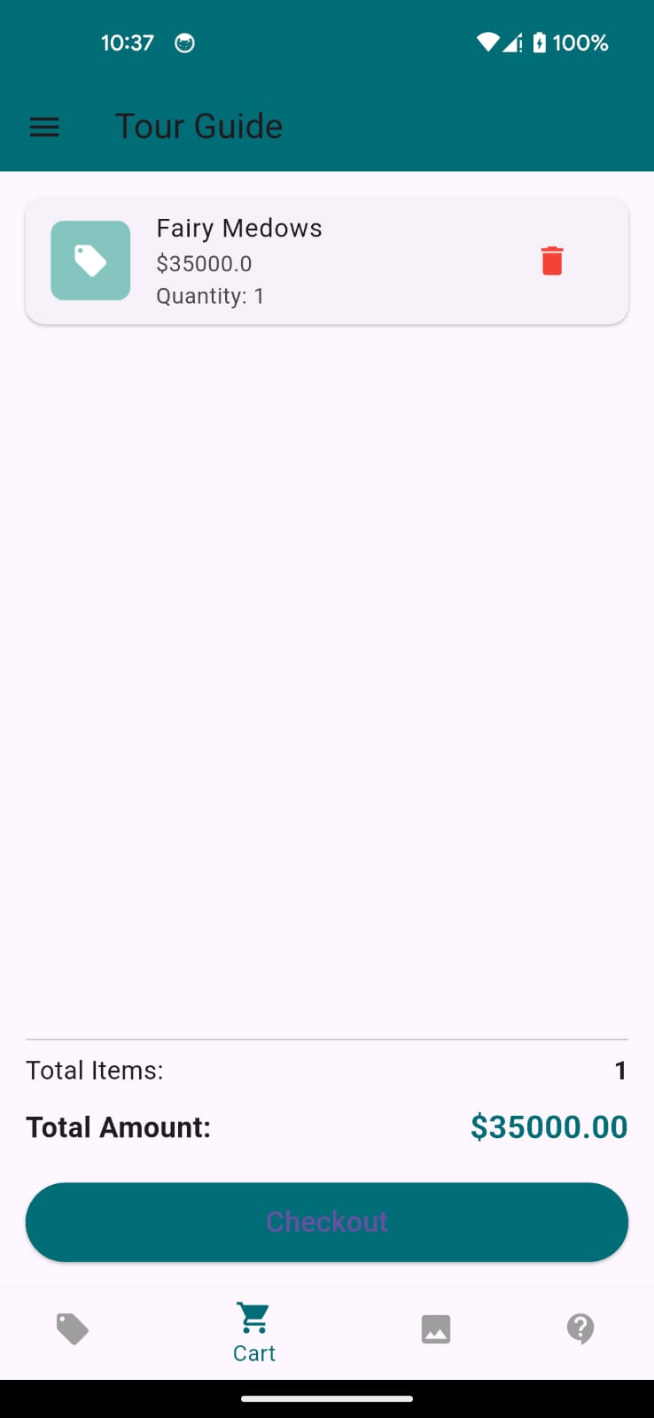

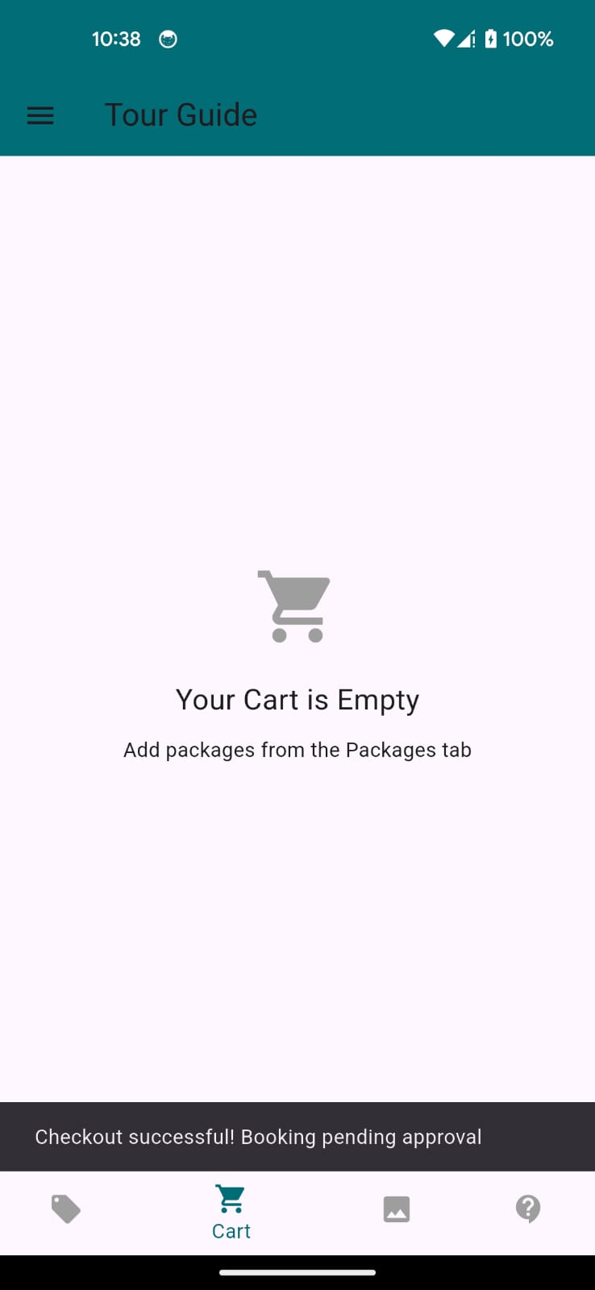
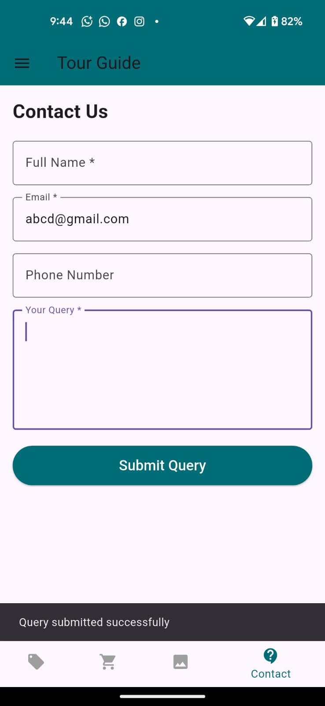

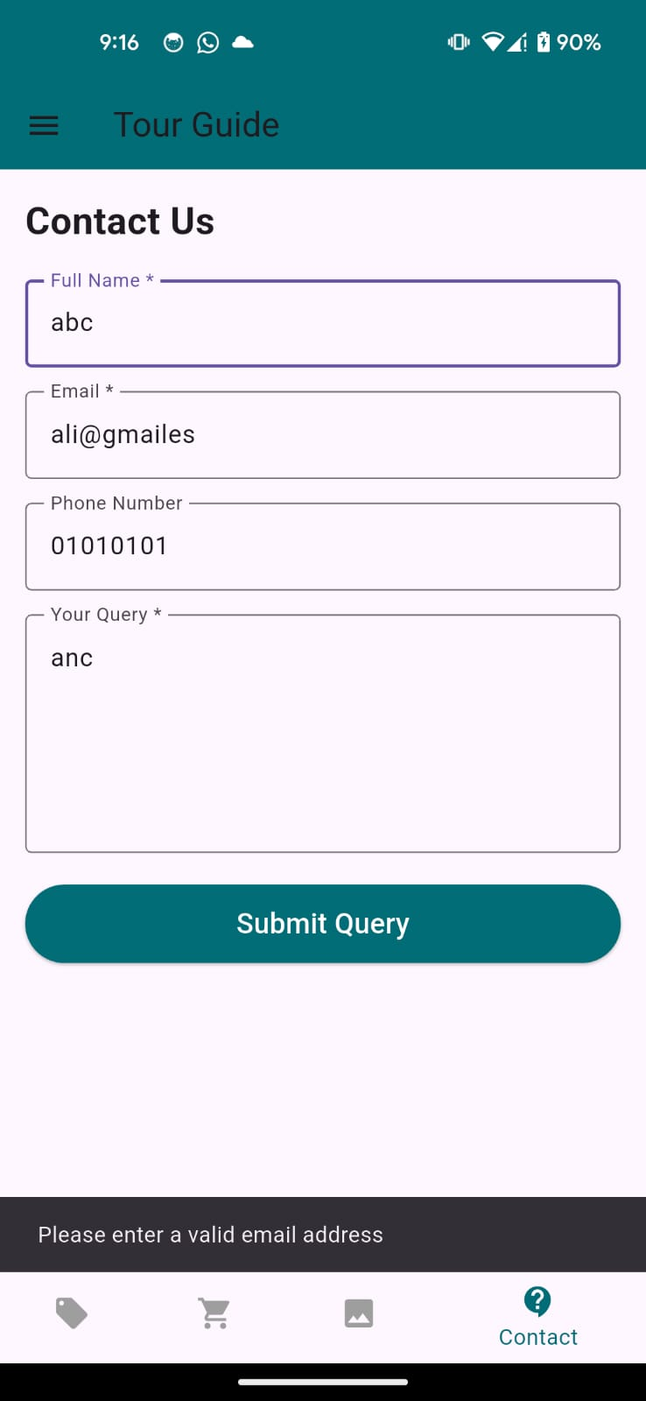
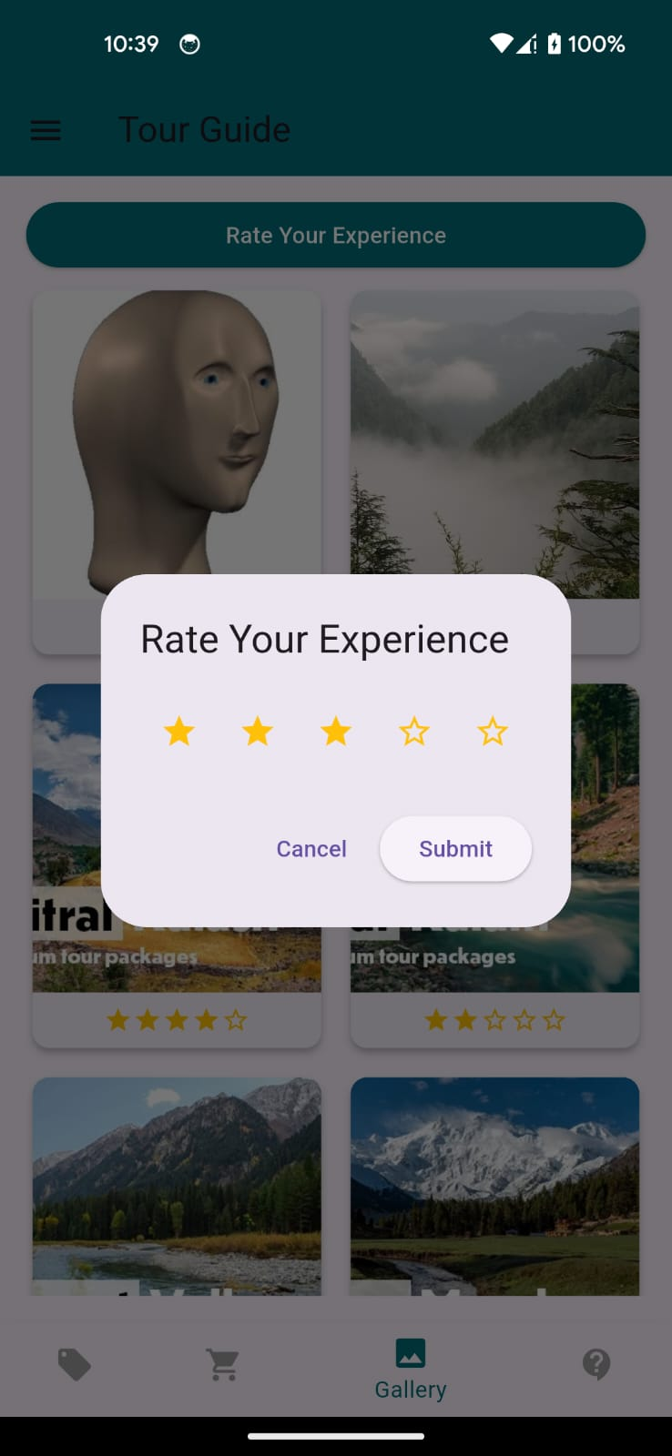
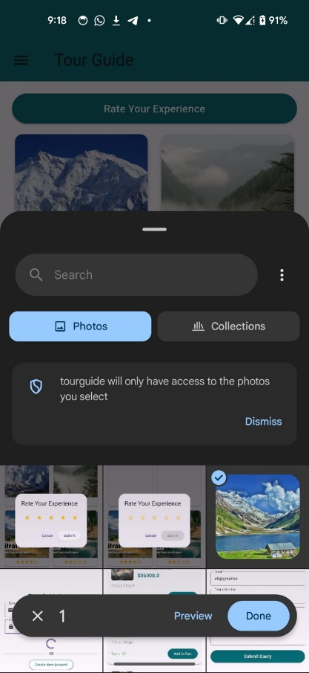
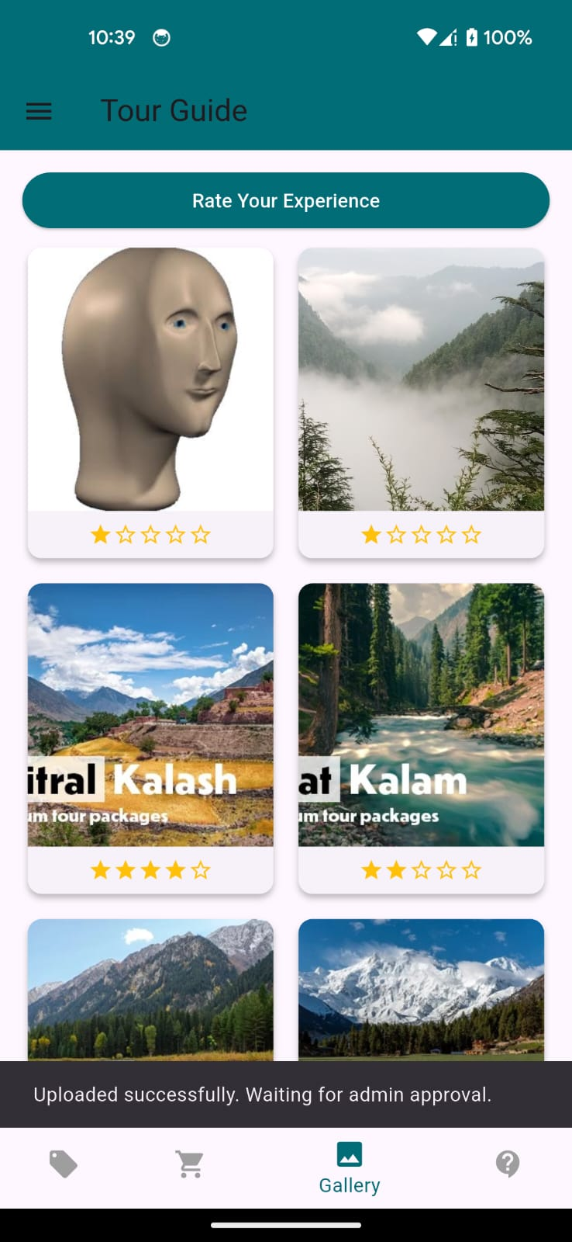
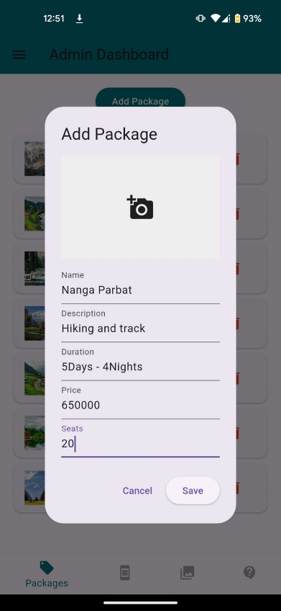
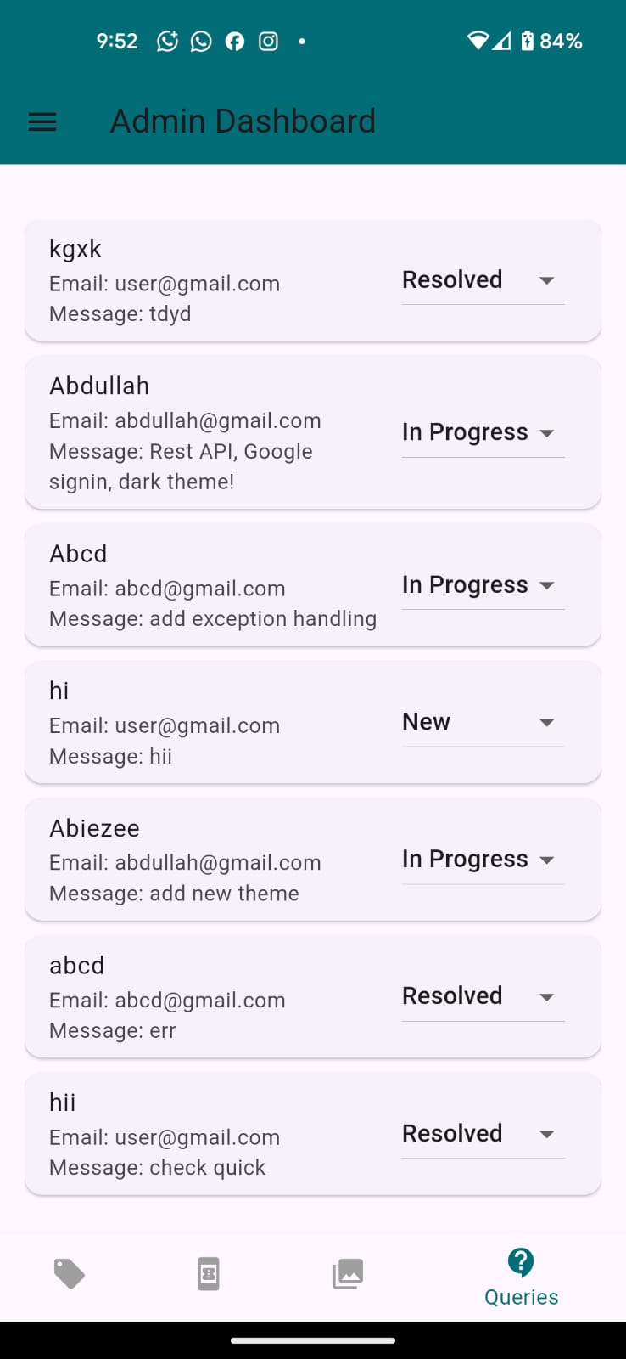

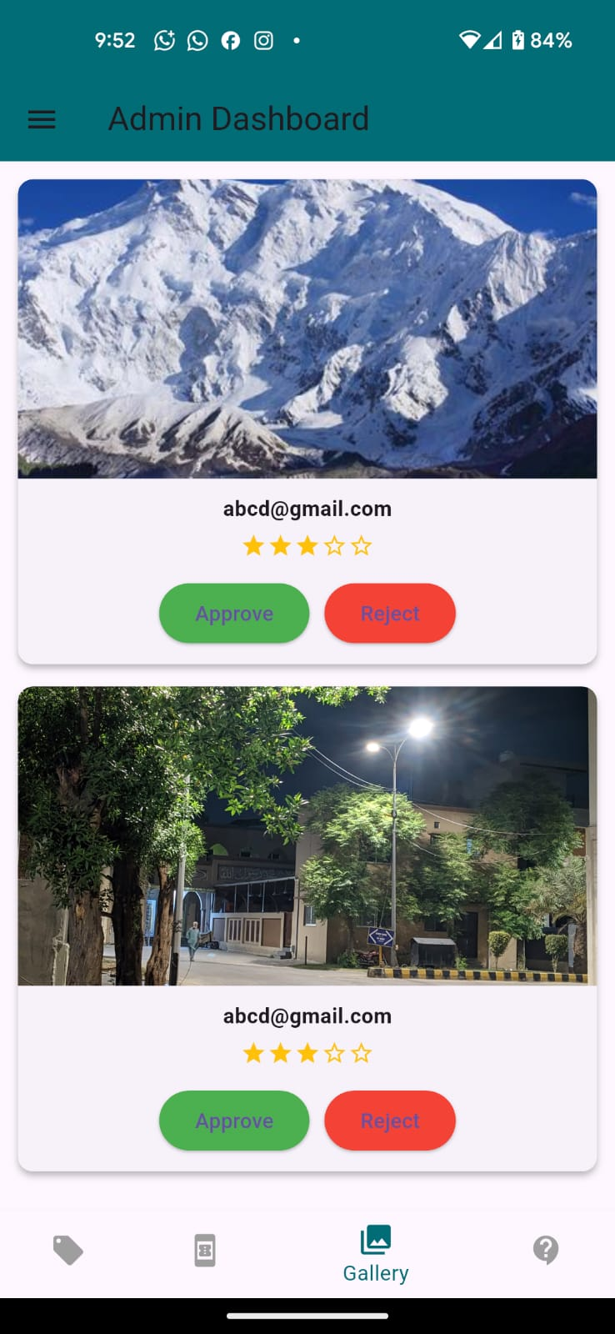
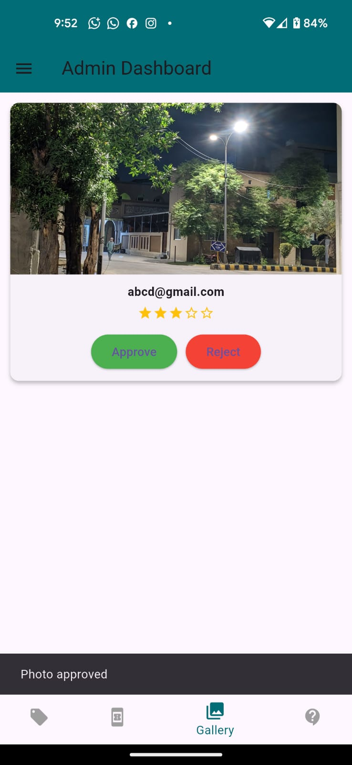
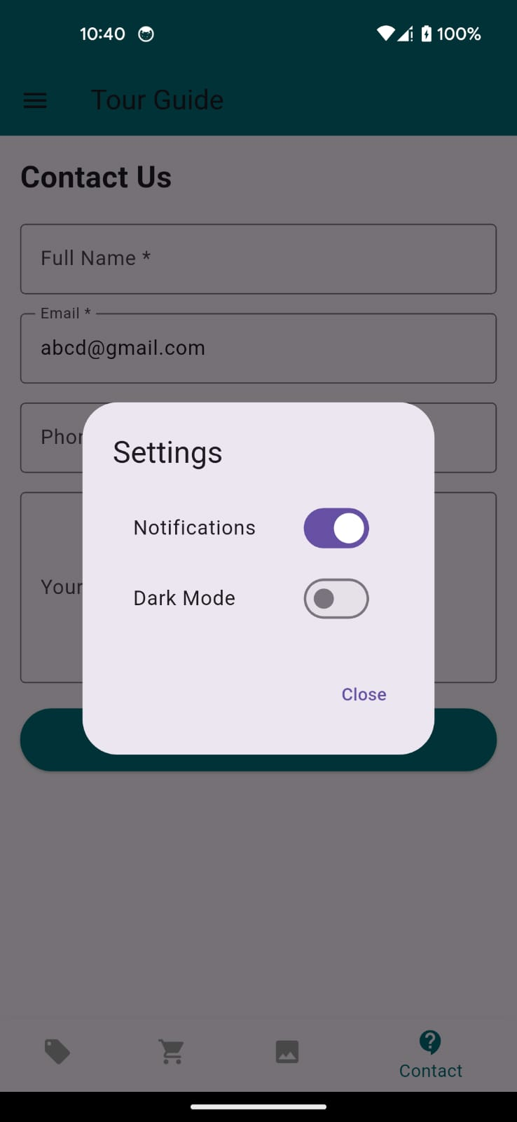

- Smoke Testing
Test Case ID | Module | Test Objective | Preconditions | Test Data | Test Steps | Expected Result | Actual Result | Status
SM-01 | Welcome Screen | Verify application launches successfully | App installed | N/A | 1. Launch App 2. Click Get Started | Welcome screen loads and navigates to Login screen | As Expected | Pass
SM-02 | Customer Login | Verify customer login functionality | Customer account exists | Email: ahmad123@gmail.com Password: Ahmad@123 | 1. Enter email 2. Enter password 3. Click Login | Customer dashboard/packages screen opens | As Expected | Pass
SM-03 | Registration | Verify customer registration | User not registered | Name: Ali Khan Email: ali.khan123@gmail.com Phone: 03011234567 Password: Ali@123 | 1. Open Register Screen 2. Fill all fields 3. Click Register | Account created successfully | As Expected | Pass
SM-04 | View Packages | Verify package list loads correctly | Customer logged in | Package: Murree Tour | 1. Open Packages Screen | Packages displayed with name, duration, price and seats | As Expected | Pass
SM-05 | Add to Cart | Verify package booking functionality | Customer logged in | Murree Tour, Price: Rs.15000 | 1. Select package 2. Click Book Now | Package added to cart successfully | As Expected | Pass
SM-06 | Checkout | Verify checkout functionality | Cart contains package | Murree Tour = Rs.15000 | 1. Open Cart 2. Click Checkout | "Checkout Successful! Booking Pending Approval" message displayed | As Expected | Pass
SM-07 | Query Submission | Verify query submission functionality | Customer logged in | Name: Ahmad Zia Email: ahmadzia@gmail.com Query: "Need details about Swat package." | 1. Open Query Form 2. Enter data 3. Submit | Query submitted successfully | As Expected | Pass
SM-08 | Admin Login | Verify admin login functionality | Admin account exists | Email: admin@tourguide.com Password: Admin@123 | 1. Enter admin credentials 2. Login | Admin dashboard opens successfully | As Expected | Pass
SM-09 | Add Package | Verify package creation by admin | Admin logged in | Name: Hunza Tour Description: 5 Days Tour Duration: 5 Days/4 Nights Price: Rs.25000 Seats: 20 | 1. Click Add Package 2. Enter details 3. Save | Package added successfully | As Expected | Pass
SM-10 | Logout | Verify logout functionality | User logged in | N/A | 1. Click Logout | User redirected to Login screen | As Expected | Pass
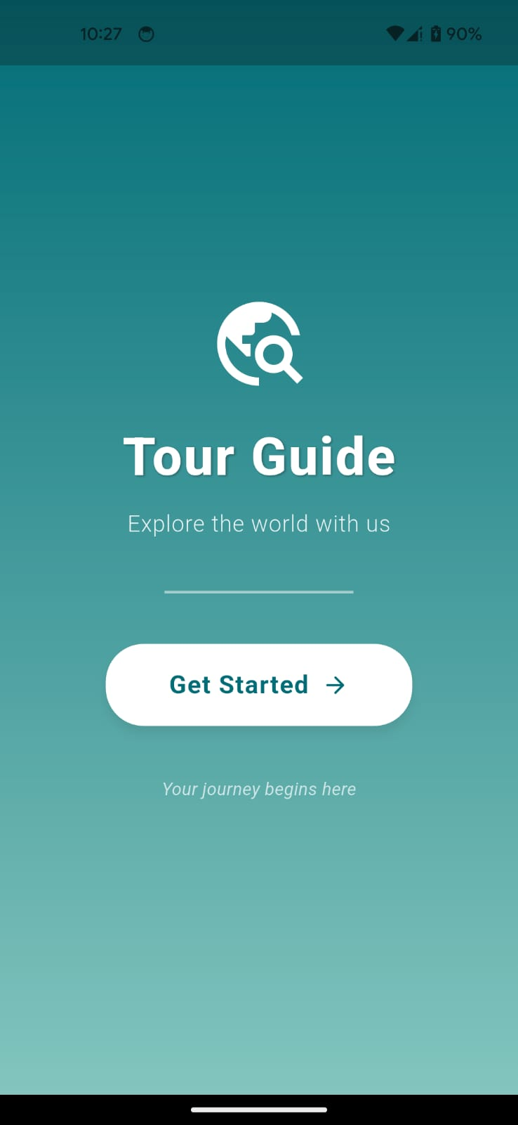
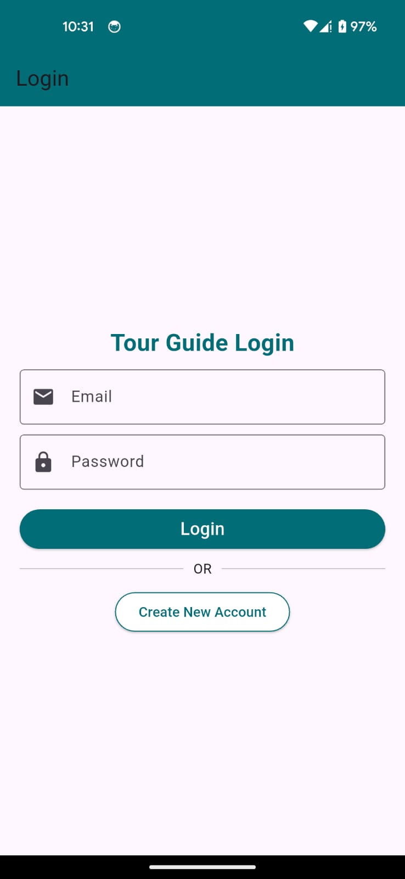


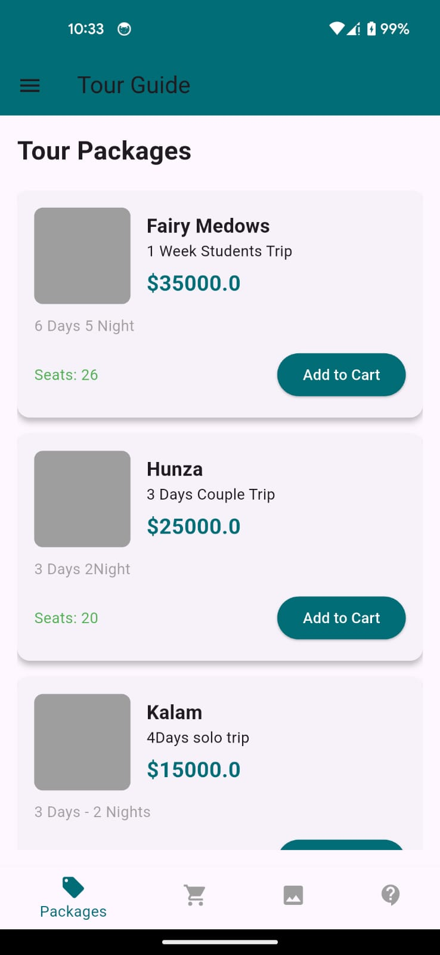






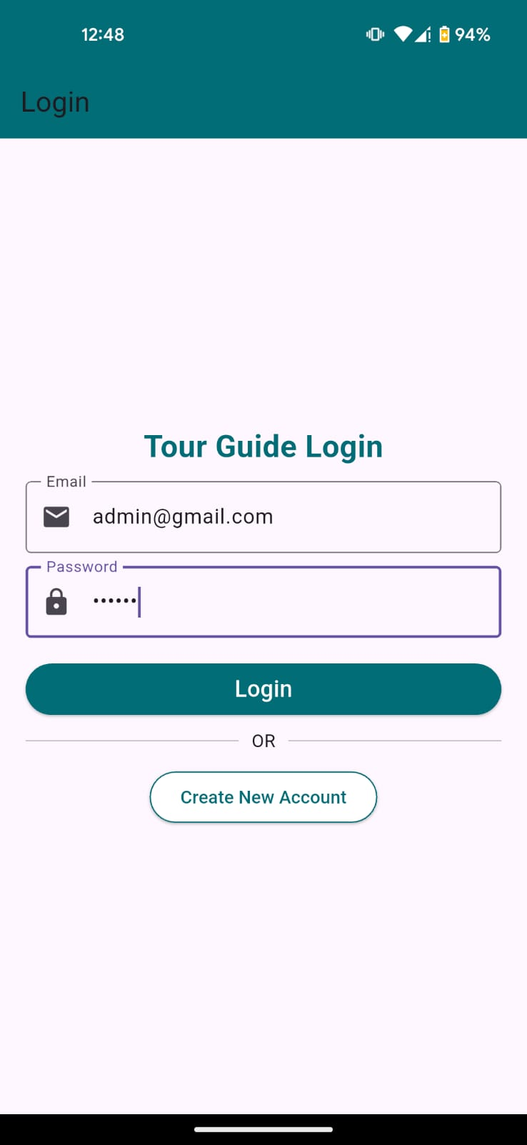
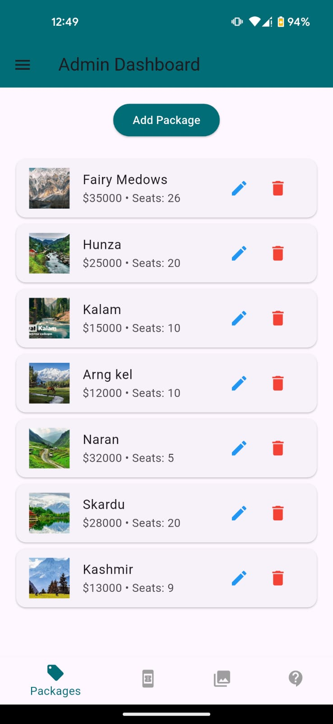

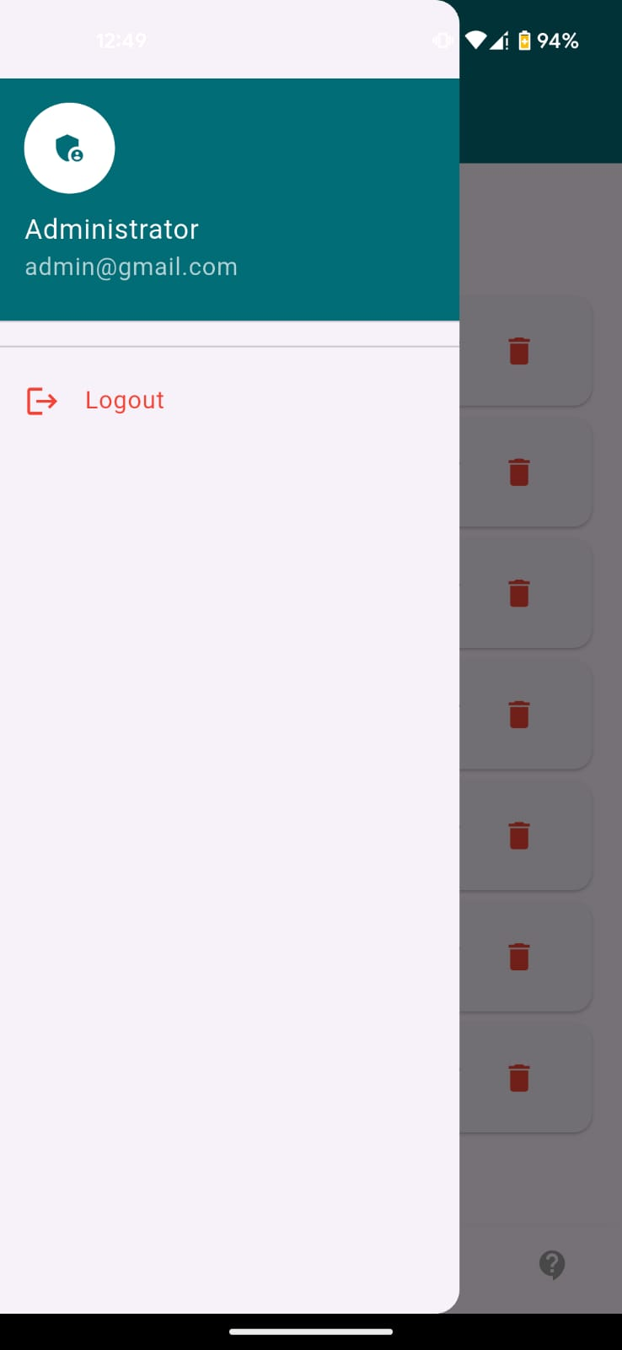

3. Sanity Testing
Test Case ID | Module | Test Objective | Preconditions | Test Data | Test Steps | Expected Result | Actual Result | Status
SN-01 | Login | Verify login works after UI changes | Customer account exists | Email: user1@gmail.com Password: User@123 | 1. Open app 2. Enter credentials 3. Click Login | Customer dashboard opens successfully | As Expected | Pass
SN-02 | Registration | Verify new user registration works | User not registered | Name: Bilal Ahmed Email: bilal.ahmed@gmail.com Phone: 03034567891 Password: Bilal@123 | 1. Open Register screen 2. Fill form 3. Submit | Account created successfully | As Expected | Pass
SN-03 | Package Listing | Verify packages load correctly | Customer logged in | Package: "Swat Valley Tour" Price: Rs.18,000$ | 1. Login 2. Open Packages screen | All packages displayed with correct details | As Expected | Pass
SN-04 | Add to Cart | Verify booking functionality | Customer logged in | Package: Hunza Tour Price: Rs.25,000 | 1. Select package 2. Click Book Now | Package added to cart | As Expected | Pass
SN-05 | Cart Total | Verify total calculation | Cart contains items | 1x Hunza Tour (25,000$) | 1. Open Cart screen | Total = Rs.25,000$displayed correctly | As Expected | Pass
SN-06 | Checkout | Verify checkout process works | Cart contains items | Cart total: Rs.25,000$ | 1. Click Checkout button | "Checkout Successful! Booking Pending Approval" message shown | As Expected | Pass
SN-07 | Query Form | Verify query submission validation | Customer logged in | Name: Ayesha Khan Email: ayesha.khan@gmail.com Query: "Is Swat trip available in December?" | 1. Open Query form 2. Submit form | Query submitted successfully | As Expected | Pass
SN-08 | Invalid Query Email | Verify email validation in query form | Customer logged in | Email: ayesha.khangmail.com | 1. Enter invalid email 2. Submit form | Error: Invalid email format | As Expected | Pass
SN-09 | Admin Login | Verify admin dashboard access | Admin account exists | Email: admin@tourguide.com Password: Admin@123 | 1. Login as admin | Admin dashboard opens successfully | As Expected | Pass
SN-10 | Package CRUD | Verify admin can add package | Admin logged in | Name: Kashmir Tour Duration: 5 Days Price: Rs.30,000 Seats: 15 | 1. Add package 2. Save | Package added successfully | As Expected | Pass












Regression Testing
Test Case ID | Module | Test Objective | Preconditions | Test Data | Test Steps | Expected Result | Actual Result | Status
RG-01 | Login | Verify login still works after new feature updates | Existing customer account | Email: usman.khan@gmail.com Password: Usman@123 | 1. Open app 2. Enter credentials 3. Login | User successfully logs in | As Expected | Pass
RG-02 | Registration | Verify registration not broken after UI changes | New user | Name: Hina Ali Email: hina.ali@gmail.com Phone: 03019876543 Password: Hina@123 | 1. Open register screen 2. Submit form | Account created successfully | As Expected | Pass
RG-03 | Package Listing | Verify packages display correctly after admin updates | Admin added packages | Package: Skardu Tour Price: Rs.28,000 | 1. Login as customer 2. Open packages screen | Updated packages shown correctly | As Expected | Pass
RG-04 | Cart Functionality | Verify cart still calculates correctly after updates | Customer logged in | 1x Hunza Tour (25000), 1x Swat Tour (18000) | 1. Add packages 2. Open cart | Total = Rs.43,000 displayed correctly | As Expected | Pass
RG-05 | Checkout | Verify checkout still clears cart after update | Cart has items | Total: Rs.43,000 | 1. Click checkout | Success message + cart emptied | As Expected | Pass
RG-06 | Query Form | Verify query validation still works | Customer logged in | Email: test.user@gmail.com Query: "Need details about Murree package" | 1. Submit query form | Query submitted successfully | As Expected | Pass
RG-07 | Invalid Email Check | Ensure email validation still active | Customer logged in | Email: test.user@com | 1. Enter invalid email 2. Submit | Validation error shown | As Expected | Pass
RG-08 | Admin Login | Verify admin login not affected | Admin account exists | Email: admin@tourguide.com Password: Admin@123 | 1. Login as admin | Admin dashboard opens | As Expected | Pass
RG-09 | Package CRUD | Verify admin add package still works | Admin logged in | Name: Fairy Meadows Tour Duration: 4 Days Price: Rs.22,000 Seats: 12 | 1. Add package 2. Save | Package added successfully | As Expected | Pass
RG-10 | Dark Mode | Verify theme toggle still works | App installed | Toggle ON/OFF | 1. Open settings 2. Switch theme | Dark mode applies correctly | As Expected | Pass













Exploratory Testing
Test Case ID | Module | Test Objective | Preconditions | Test Data | Test Steps | Expected Result | Actual Result | Status
EX-01 | Login | Check system behavior with incorrect email format | App installed | Email: ahmad@com Password: 123456 | 1. Enter invalid email 2. Click Login | Validation error shown | As Expected | Pass
EX-02 | Registration | Test duplicate account creation | User already exists | Email: ali.khan@gmail.com | 1. Register with same email | "Email already exists" message | As Expected | Pass
EX-03 | Packages Screen | Scroll behavior with many packages | Admin added multiple packages | 10+ packages list | 1. Scroll package list | Smooth scrolling without lag | As Expected | Pass
EX-04 | Cart Edge Case | Remove all items from cart | Cart has items | Multiple packages | 1. Remove all items 2. Open cart | Empty cart message displayed | As Expected | Pass
EX-05 | Checkout Edge Case | Attempt checkout with empty cart | Cart empty | N/A | 1. Click Checkout | Warning message or blocked action | As Expected | Pass
EX-06 | Query Form | Submit partially filled form | Customer logged in | Name: Ali Email empty Query filled | 1. Submit form | Validation error for missing fields | As Expected | Pass
EX-07 | Query Form | Invalid email format test | Customer logged in | Email: ali@.com | 1. Enter invalid email 2. Submit | Email validation error | As Expected | Pass
EX-08 | Rating System | Test boundary rating values | Customer logged in | Rating: 1 star & 5 stars | 1. Submit ratings | Rating stored correctly | As Expected | Pass
EX-09 | Gallery Upload | Upload unsupported file type | Customer logged in | File: .txt file | 1. Upload file | Error or rejection message | As Expected | Pass
EX-10 | Dark Mode | Toggle repeatedly | App running | ON/OFF multiple times | 1. Switch theme multiple times | UI updates correctly without crash | As Expected | Pass




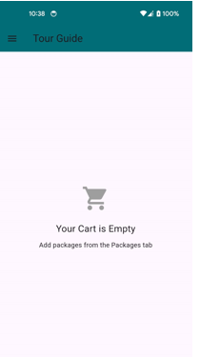
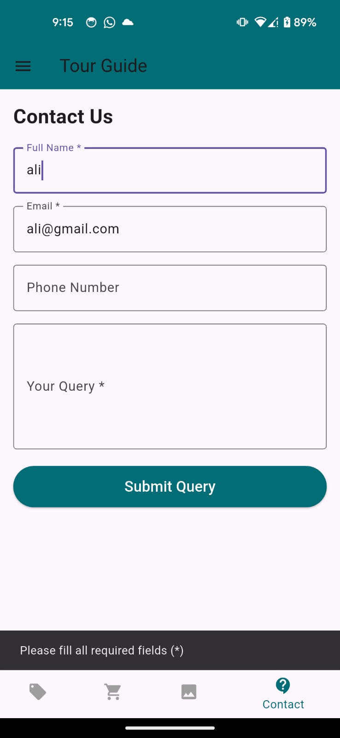





Usability Testing

Test Case ID | Module | Test Objective | Preconditions | Test Data | Test Steps | Expected Result | Actual Result | Status
US-01 | Welcome Screen | Verify user understands navigation easily | App installed | N/A | 1. Open app 2. View welcome screen | Clear "Get Started" button visible and easy to understand | As Expected | Pass
US-02 | Login Screen | Check ease of login process | User account exists | Email: user1@gmail.com Password: User@123 | 1. Enter credentials 2. Click Login | Simple and smooth login process | As Expected | Pass
US-03 | Registration | Check form usability | New user | Name: Hassan Ali Email: hassan.ali@gmail.com Phone: 03012345678 Password: Hassan@123 | 1. Fill form 2. Submit | Form is easy to fill with clear labels and validation | As Expected | Pass
US-04 | Package Browsing | Check ease of browsing packages | Customer logged in | Package: Hunza Tour, Skardu Tour | 1. Scroll packages screen | Packages clearly displayed with price, duration, seats | As Expected | Pass
US-05 | Add to Cart | Check booking usability | Customer logged in | Murree Tour Rs.15,000 | 1. Click Book Now 2. Add to cart | One-click booking adds package easily | As Expected | Pass
US-06 | Cart Screen | Check cart readability | Items in cart | 2 packages total Rs.40,000 | 1. Open cart | Clear layout showing items and total price | As Expected | Pass
US-07 | Checkout Process | Check checkout simplicity | Cart contains items | Total Rs.40,000 | 1. Click checkout | Simple confirmation message shown | As Expected | Pass
US-08 | Query Form | Check form clarity | Customer logged in | Email: ali.khan@gmail.com Query text | 1. Fill form 2. Submit | Easy-to-use form with validation messages | As Expected | Pass
US-09 | Rating System | Check rating usability | Customer logged in | 4-star rating | 1. Select stars 2. Submit | Simple star selection interface | As Expected | Pass
US-10 | Admin Dashboard | Check admin usability | Admin logged in | N/A | 1. Open dashboard | Clear navigation for CRUD and approvals | As Expected | Pass






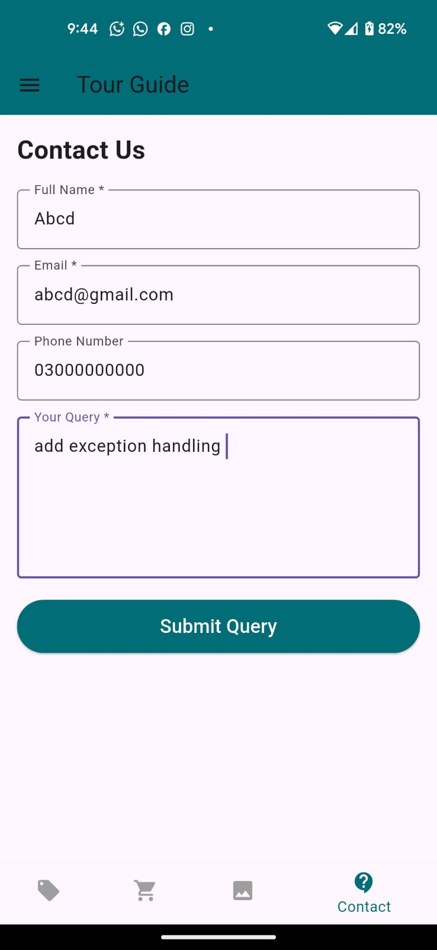




Black-Box Testing:
- Equivalence Partitioning
Test Case ID | Module | Test Objective | Preconditions | Test Data | Test Steps | Expected Result | Actual Result | Status
EP-01 | Customer Login | Verify login with valid credentials | Registered customer exists | Email: ahmad.zia@gmail.com Password: Ahmad@123 | Enter credentials and click Login | Login successful | As Expected | Pass
EP-02 | Customer Login | Verify login with invalid email format | User on login page | Email: ahmad.gmail.com Password: Ahmad@123 | Enter credentials and click Login | Email validation error displayed | As Expected | Pass
EP-03 | Customer Login | Verify login with incorrect password | Registered customer exists | Email: ahmad.zia@gmail.com Password: 123456 | Enter credentials and click Login | Invalid credentials message displayed | As Expected | Pass
EP-04 | Registration | Verify registration with valid data | User not registered | Name: Ali Khan, Email: ali.khan@gmail.com, Phone: 03012345678, Password: Ali@123 | Fill form and submit | Account created successfully | As Expected | Pass
EP-05 | Registration | Verify duplicate email detection | Email already registered | Email: ahmad.zia@gmail.com | Fill registration form and submit | Email already exists message displayed | As Expected | Pass
EP-06 | Registration | Verify invalid email class | User not registered | Email: ali.khangmail.com | Fill form and submit | Invalid email error displayed | As Expected | Pass
EP-07 | Query Form | Verify valid query submission | Customer logged in | Name: Ahmad Zia, Email: ahmad.zia@gmail.com, Query: Need details about Hunza package | Submit query | Query submitted successfully | As Expected | Pass
EP-08 | Query Form | Verify invalid email in query form | Customer logged in | Email: ahmad@gmail | Submit query | Validation error displayed | As Expected | Pass
EP-09 | Package Booking | Verify booking with valid package | Customer logged in | Package: Hunza Tour (Rs.25,000) | Click Book Now | Package added to cart | As Expected | Pass
EP-10 | Rating System | Verify valid rating class | Customer logged in | Rating: 5 Stars | Submit rating | Rating saved successfully | As Expected | Pass





- Black-Box Testing:

Equivalence Partitioning.
Test Case ID | Module | Test Objective | Preconditions | Test Data | Test Steps | Expected Result | Actual Result | Status
EP-01 | Customer Login | Verify login with valid credentials | Registered customer exists | Email: ahmad.zia@gmail.com Password: Ahmad@123 | Enter credentials and click Login | Login successful | As Expected | Pass
EP-02 | Customer Login | Verify login with invalid email format | User on login page | Email: ahmad.gmail.com Password: Ahmad@123 | Enter credentials and click Login | Email validation error displayed | As Expected | Pass
EP-03 | Customer Login | Verify login with incorrect password | Registered customer exists | Email: ahmad.zia@gmail.com Password: 123456 | Enter credentials and click Login | Invalid credentials message displayed | As Expected | Pass
EP-04 | Registration | Verify registration with valid data | User not registered | Name: Ali Khan, Email: ali.khan@gmail.com, Phone: 03012345678, Password: Ali@123 | Fill form and submit | Account created successfully | As Expected | Pass
EP-05 | Registration | Verify duplicate email detection | Email already registered | Email: ahmad.zia@gmail.com | Fill registration form and submit | Email already exists message displayed | As Expected | Pass
EP-06 | Registration | Verify invalid email class | User not registered | Email: ali.khangmail.com | Fill form and submit | Invalid email error displayed | As Expected | Pass
EP-07 | Query Form | Verify valid query submission | Customer logged in | Name: Ahmad Zia, Email: ahmad.zia@gmail.com, Query: Need details about Hunza package | Submit query | Query submitted successfully | As Expected | Pass
EP-08 | Query Form | Verify invalid email in query form | Customer logged in | Email: ahmad@gmail | Submit query | Validation error displayed | As Expected | Pass
EP-09 | Package Booking | Verify booking with valid package | Customer logged in | Package: Hunza Tour (Rs.25,000) | Click Book Now | Package added to cart | As Expected | Pass
EP-10 | Rating System | Verify valid rating class | Customer logged in | Rating: 5 Stars | Submit rating | Rating saved successfully | As Expected | Pass






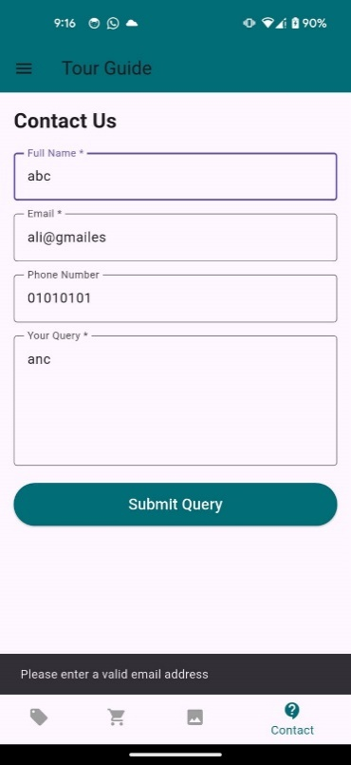





Boundary Value Analysis

Test Case ID | Module | Test Objective | Preconditions | Test Data | Test Steps | Expected Result | Actual Result | Status
BVA-01 | Registration | Verify minimum valid name length | Registration page open | Name: A, Email: a@gmail.com, Phone: 03012345678, Password: Ali@123 | Fill form and submit | Registration successful | As Expected | Pass
BVA-02 | Registration | Verify empty name field | Registration page open | Name: "" | Leave name empty and submit | Validation error displayed | As Expected | Pass
BVA-03 | Registration | Verify phone number with exactly 11 digits | Registration page open | Phone: 03012345678 | Fill form and submit | Registration successful | As Expected | Pass
BVA-04 | Registration | Verify phone number less than 11 digits | Registration page open | Phone: 0301234567 | Fill form and submit | Validation error displayed | As Expected | Pass
BVA-05 | Registration | Verify password at minimum accepted length | Registration page open | Password: Abc123 | Fill form and submit | Registration successful | As Expected | Pass
BVA-06 | Registration | Verify password below minimum length | Registration page open | Password: Ab12 | Fill form and submit | Validation error displayed | As Expected | Pass
BVA-07 | Package Seats | Verify minimum seat value | Admin logged in | Seats: 1 | Create package | Package created successfully | As Expected | Pass
BVA-08 | Package Seats | Verify zero seat value | Admin logged in | Seats: 0 | Create package | Validation error displayed | As Expected | Pass
BVA-09 | Rating System | Verify minimum rating value | Customer logged in | Rating: 1 Star | Submit rating | Rating saved successfully | As Expected | Pass
BVA-10 | Rating System | Verify maximum rating value | Customer logged in | Rating: 5 Stars | Submit rating | Rating saved successfully | As Expected | Pass

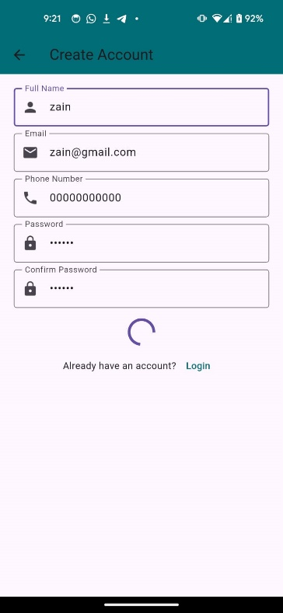
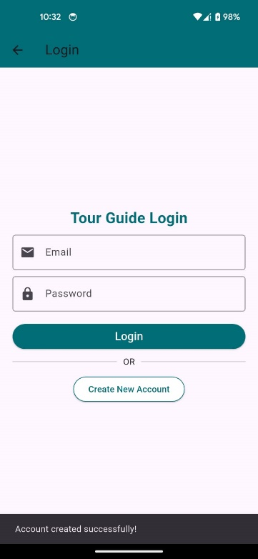





Decision Table Testing
Test Case ID | Module | Test Objective | Preconditions | Test Data | Test Steps | Expected Result | Actual Result | Status
DT-01 | Customer Login | Verify login when email and password are valid | Customer account exists | Email: ahmad.zia@gmail.com Password: Ahmad@123 | Enter credentials and click Login | Login successful | As Expected | Pass
DT-02 | Customer Login | Verify login with valid email and wrong password | Customer account exists | Email: ahmad.zia@gmail.com Password: Wrong123 | Enter credentials and click Login | Invalid credentials message | As Expected | Pass
DT-03 | Customer Login | Verify login with invalid email and valid password | Customer account exists | Email: ahmadgmail.com Password: Ahmad@123 | Enter credentials and click Login | Email validation error | As Expected | Pass
DT-04 | Customer Login | Verify login with both invalid email and password | Customer account exists | Email: ahmadgmail Password: 111111 | Enter credentials and click Login | Validation/error message displayed | As Expected | Pass
DT-05 | Registration | Verify registration when all fields are valid | User not registered | Name: Ali Khan Email: ali.khan@gmail.com Phone: 03012345678 Password: Ali@123 Confirm: Ali@123 | Fill form and submit | Account created successfully | As Expected | Pass
DT-06 | Registration | Verify registration when passwords do not match | User not registered | Password: Ali@123 Confirm: Ali@321 | Fill form and submit | User already registered | As Expected | Pass
DT-07 | Query Form | Verify query submission with valid email and query | Customer logged in | Email: ahmad.zia@gmail.com Query: Need details about Skardu Tour | Submit form | Query submitted successfully | As Expected | Pass
DT-08 | Query Form | Verify query submission with invalid email | Customer logged in | Email: ahmad@gmail Query: Need details about Skardu Tour | Submit form | Email validation error | As Expected | Pass
DT-09 | Admin Image Approval | Verify image approval action | Admin logged in | Customer Image Request | Click Approve | Image appears in Gallery | As Expected | Pass
DT-10 | Admin Image Approval | Verify image rejection action | Admin logged in | Customer Image Request | Click Reject | Image not displayed in Gallery | As Expected | Pass










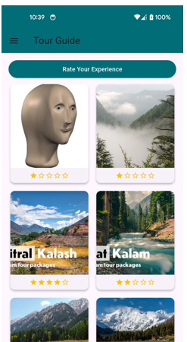

State Transition Testing
Test Case ID | Module | Test Objective | Preconditions | Test Data | Test Steps | Expected Result | Actual Result | Status
ST-01 | Login | Verify transition from Login Screen to Customer Dashboard | Customer account exists | Email: ahmad.zia@gmail.com Password: Ahmad@123 | Enter credentials and click Login | State changes from Login → Customer Dashboard | As Expected | Pass
ST-02 | Login | Verify system remains on Login Screen after invalid login | Customer account exists | Email: ahmad.zia@gmail.com Password: Wrong123 | Enter credentials and click Login | Remains on Login Screen with error message | As Expected | Pass
ST-03 | Registration | Verify transition from Registration to Login Screen | New user | Name: Ali Khan Email: ali.khan@gmail.com Phone: 03012345678 Password: Ali@123 | Register account | Registration Successful → Login Screen | As Expected | Pass
ST-04 | Package Booking | Verify transition from Package Screen to Cart | Customer logged in | Package: Hunza Tour (Rs.25,000) | Click Book Now | Package added and state changes to Updated Cart | As Expected | Pass
ST-05 | Checkout | Verify transition from Cart to Booking History | Cart contains package | Hunza Tour Rs.25,000 | Click Checkout | Booking created and status becomes Pending | As Expected | Pass
ST-06 | Query Management | Verify query state transition | Customer logged in | Query: "Need details about Skardu Tour" | Submit query | Query state changes from New → Submitted | As Expected | Pass
ST-07 | Admin Query Management | Verify query status update | Admin logged in | Query Status = Resolved | Open query and change status | State changes New → In Progress → Resolved | As Expected | Pass
ST-08 | Image Approval | Verify image approval state transition | Admin logged in | Uploaded image request | Click Approve | State changes Pending → Approved → Visible in Gallery | As Expected | Pass
ST-09 | Image Rejection | Verify image rejection state transition | Admin logged in | Uploaded image request | Click Reject | State changes Pending → Rejected → Hidden from Gallery | As Expected | Pass
ST-10 | Logout | Verify logout state transition | User logged in | N/A | Click Logout | State changes Dashboard → Login Screen | As Expected | Pass






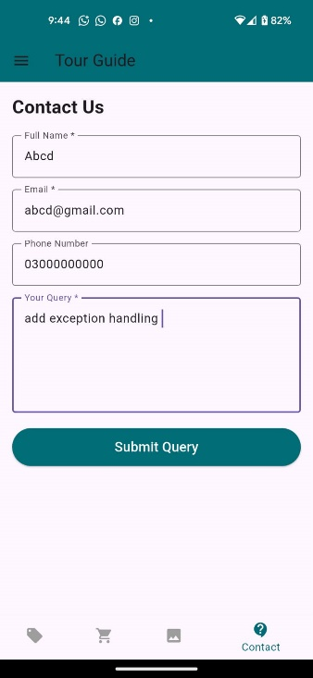

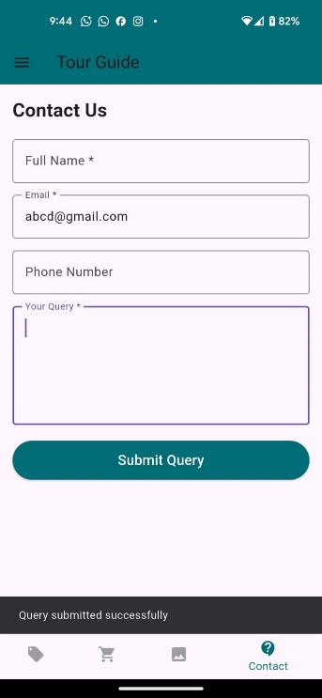

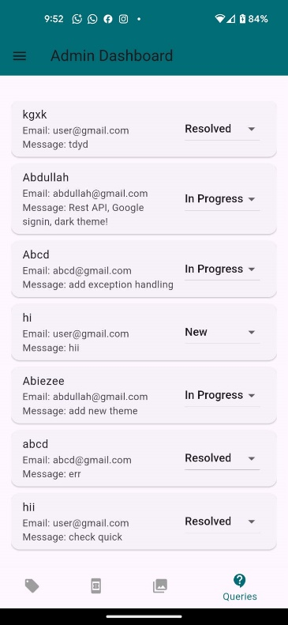
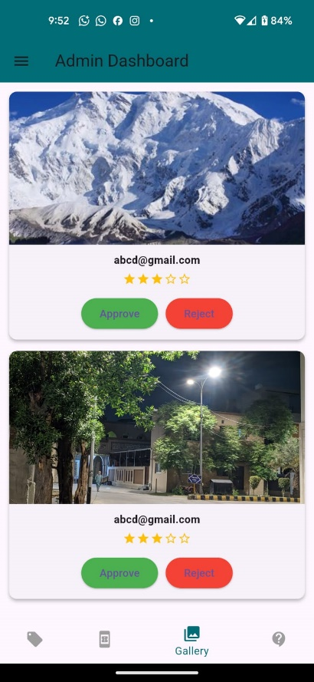



Use Case Testing
Test Case ID | Module | Test Objective | Preconditions | Test Data | Test Steps | Expected Result | Actual Result | Status
UC-01 | Customer Registration | Verify complete customer registration flow | User not registered | Name: Ali Khan, Email: ali.khan@gmail.com, Phone: 03012345678, Password: Ali@123 | Open Register → Fill form → Submit | Customer account created successfully | As Expected | Pass
UC-02 | Customer Login | Verify complete customer login flow | Customer account exists | Email: ahmad.zia@gmail.com, Password: Ahmad@123 | Open Login → Enter credentials → Login | Customer dashboard/packages screen opens | As Expected | Pass
UC-03 | View Packages | Verify customer can view tour packages | Customer logged in | Package: Hunza Tour, Swat Tour | Open Packages screen | Packages displayed with price, duration, and seats | As Expected | Pass
UC-04 | Book Package | Verify customer can book a package | Customer logged in | Package: Hunza Tour (Rs.25,000) | Select package → Click Book Now | Package added to cart successfully | As Expected | Pass
UC-05 | Checkout | Verify complete checkout flow | Cart contains package | Total: Rs.25,000 | Open Cart → Click Checkout | Checkout successful and cart emptied | As Expected | Pass
UC-06 | Submit Query | Verify customer can submit a query | Customer logged in | Name: Ahmad Zia, Email: ahmad.zia@gmail.com, Query: Need details about Skardu Tour | Open Query Form → Fill form → Submit | Query submitted successfully | As Expected | Pass
UC-07 | Give Rating | Verify customer can submit rating | Customer logged in | Rating: 5 Stars | Open Rating Screen → Select 5 stars → Submit | Rating saved successfully | As Expected | Pass
UC-08 | Upload Photo | Verify customer can request image upload | Customer logged in | Image: hunza.jpg | Open Upload Screen → Select image → Upload | Waiting for admin approval message displayed | As Expected | Pass
UC-09 | Admin Package Management | Verify admin can add package | Admin logged in | Name: Fairy Meadows Tour, Duration: 4 Days, Price: Rs.22,000, Seats: 12 | Open Dashboard → Add Package → Save | Package added successfully | As Expected | Pass
UC-10 | Admin Image Approval | Verify admin can approve uploaded image | Admin logged in | Pending image request | Open Photo Requests → Click Approve | Image appears in Gallery page | As Expected | Pass
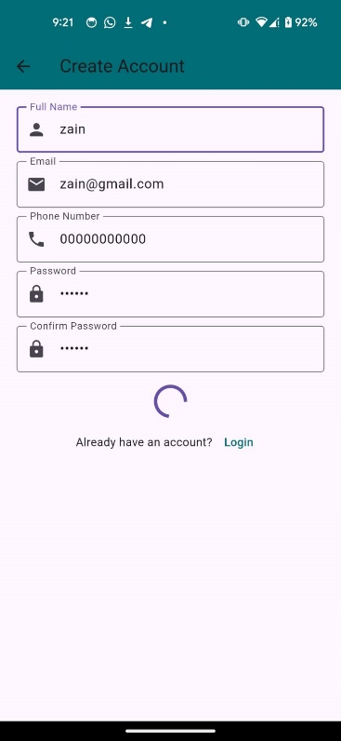














Cause-Effect Graphing
Test Case ID | Module | Test Objective | Preconditions | Test Data | Test Steps | Expected Result | Actual Result | Status
CE-01 | Customer Login | Verify successful login when valid email and password are entered | Customer account exists | Email: ahmad.zia@gmail.com Password: Ahmad@123 | Enter credentials and click Login | Customer dashboard opens successfully | As Expected | Pass
CE-02 | Customer Login | Verify error when password is incorrect | Customer account exists | Email: ahmad.zia@gmail.com Password: Wrong123 | Enter credentials and click Login | Invalid credentials error displayed | As Expected | Pass
CE-03 | Customer Login | Verify error when email format is invalid | Customer account exists | Email: ahmad.gmail.com Password: Ahmad@123 | Enter credentials and click Login | Email validation error displayed | As Expected | Pass
CE-04 | Registration | Verify account creation when all inputs are valid | User not registered | Name: Ali Khan, Email: ali.khan@gmail.com, Phone: 03012345678, Password: Ali@123, Confirm: Ali@123 | Fill form and submit | Account created successfully | As Expected | Pass
CE-05 | Registration | Verify error when passwords do not match | User not registered | Password: Ali@123 Confirm: Ali@321 | Fill form and submit | Password mismatch error displayed | As Expected | Pass
CE-06 | Registration | Verify error when email already exists | Email already registered | Email: ahmad.zia@gmail.com | Fill form and submit | Email already exists message displayed | As Expected | Pass
CE-07 | Query Form | Verify successful query submission when valid data is entered | Customer logged in | Name: Ahmad Zia, Email: ahmad.zia@gmail.com, Query: Need details about Hunza Tour | Submit query | Query submitted successfully | As Expected | Pass
CE-08 | Query Form | Verify validation when query field is empty | Customer logged in | Name: Ahmad Zia, Email: ahmad.zia@gmail.com, Query: Empty | Submit query | Query validation error displayed | As Expected | Pass
CE-09 | Gallery Approval | Verify image appears in gallery after admin approval | Admin logged in | Image: hunza_trip.jpg | Approve uploaded image | Image displayed in gallery | As Expected | Pass
CE-10 | Gallery Approval | Verify image does not appear in gallery after rejection | Admin logged in | Image: swat_trip.jpg | Reject uploaded image | Image not displayed in gallery | As Expected | Pass















White-Box Testing:

Statement Coverage

Test Case ID | Module | Test Objective | Preconditions | Test Data | Test Steps | Expected Result | Actual Result | Status
SC-01 | Customer Login | Execute successful login statements | Customer account exists | Email: ahmad.zia@gmail.com Password: Ahmad@123 | Enter valid credentials and click Login | All login success statements executed | As Expected | Pass
SC-02 | Customer Login | Execute invalid password statement | Customer account exists | Email: ahmad.zia@gmail.com Password: Wrong123 | Enter wrong password and click Login | Error statement executed | As Expected | Pass
SC-03 | Registration | Execute successful registration statements | New user | Name: Ali Khan Email: ali.khan@gmail.com Phone: 03012345678 Password: Ali@123 | Complete registration form and submit | User creation statements executed | As Expected | Pass
SC-04 | Registration | Execute duplicate email statement | Existing email present | Email: ahmad.zia@gmail.com | Register with existing email | Duplicate email validation statement executed | As Expected | Pass
SC-05 | Package Booking | Execute add-to-cart statements | Customer logged in | Hunza Tour Rs.25,000 | Click Book Now | Cart insertion statements executed | As Expected | Pass
SC-06 | Checkout | Execute checkout success statements | Cart contains package | Total: Rs.25,000 | Click Checkout | Checkout and cart clearing statements executed | As Expected | Pass
SC-07 | Query Form | Execute successful query submission statements | Customer logged in | Email: ahmad.zia@gmail.com Query: Need details about Swat Tour | Submit query | Query storage statements executed | As Expected | Pass
SC-08 | Rating System | Execute rating submission statements | Customer logged in | Rating: 5 Stars | Submit rating | Rating save statements executed | As Expected | Pass
SC-09 | Admin Package CRUD | Execute package creation statements | Admin logged in | Skardu Tour, Rs.30,000, Seats:15 | Add package and save | Package creation statements executed | As Expected | Pass
SC-10 | Image Approval | Execute image approval statements | Admin logged in | Pending image request | Click Approve | Approval and gallery display statements executed | As Expected | Pass












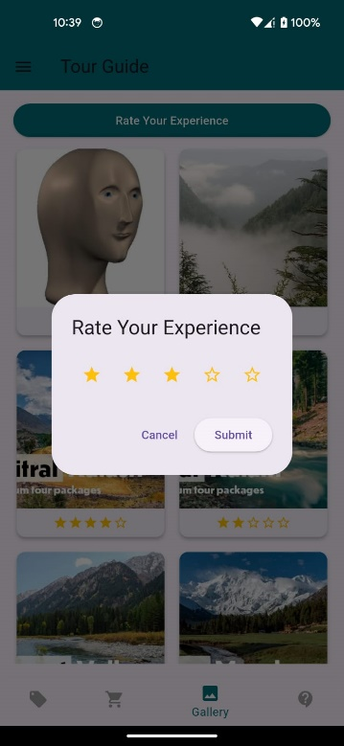



Branch Coverage

Test Case ID | Module | Test Objective | Preconditions | Test Data | Test Steps | Expected Result | Actual Result | Status
BC-01 | Customer Login | Execute TRUE branch (valid credentials) | Customer account exists | Email: ahmad.zia@gmail.com Password: Ahmad@123 | Enter valid credentials and click Login | Login successful, Dashboard opens | As Expected | Pass
BC-02 | Customer Login | Execute FALSE branch (invalid credentials) | Customer account exists | Email: ahmad.zia Password: Ahmad123 | Enter invalid email and click Login | Error message displayed | As Expected | Pass
BC-03 | Registration | Execute TRUE branch (new email) | User not registered | Email: ali.khan@gmail.com | Complete registration and submit | Account created successfully | As Expected | Pass
BC-04 | Registration | Execute FALSE branch (existing email) | Email already exists | Email: ahmad.zia@gmail.com | Submit registration form | "Email already exists" error shown | As Expected | Pass
BC-05 | Query Form | Execute TRUE branch (valid email format) | Customer logged in | Email: user@gmail.com Query: Need package details | Submit query | Query submitted successfully | As Expected | Pass
BC-06 | Query Form | Execute FALSE branch (invalid email format) | Customer logged in | Email: usergmail.com Query: Need package details | Submit query | Email validation error shown | As Expected | Pass
BC-07 | Checkout | Execute TRUE branch (cart contains items) | Cart contains Hunza Tour | Total: Rs.25,000 | Click Checkout | Checkout successful and cart emptied | As Expected | Pass
BC-08 | Checkout | Execute FALSE branch (empty cart) | Cart empty | No package selected | Click Checkout | Checkout blocked / warning shown | As Expected | Pass
BC-09 | Image Approval | Execute TRUE branch (Approve image) | Admin logged in | Pending image: hunza.jpg | Click Approve | Image appears in Gallery | As Expected | Pass
BC-10 | Image Approval | Execute FALSE branch (Reject image) | Admin logged in | Pending image: swat.jpg | Click Reject | Image not displayed in Gallery | As Expected | Pass
















Condition Coverage
Test Case ID | Module | Test Objective | Preconditions | Test Data | Test Steps | Expected Result | Actual Result | Status
CC-01 | Login | Condition: Valid email format = TRUE | Customer exists | Email: ahmad@gmail.com Password: 123456 | Enter credentials and login | Email accepted for processing | As Expected | Pass
CC-02 | Login | Condition: Valid email format = FALSE | Customer exists | Email: ahmadgmail.com Password: 123456 | Enter credentials and login | Email validation error | As Expected | Pass
CC-03 | Login | Condition: Password correct = TRUE | Customer exists | Email: ahmad@gmail.com Password: Ahmad@123 | Login attempt | Login successful | As Expected | Pass
CC-04 | Login | Condition: Password correct = FALSE | Customer exists | Email: ahmad@gmail.com Password: Wrong123 | Login attempt | Login failed | As Expected | Pass
CC-05 | Registration | Condition: Email exists = TRUE | Email already registered | Email: ahmad@gmail.com | Submit form | "Email already exists" error | As Expected | Pass
CC-06 | Registration | Condition: Email exists = FALSE | New user | Email: newuser@gmail.com | Submit form | Account created | As Expected | Pass
CC-07 | Query Form | Condition: Email valid format = TRUE | User logged in | Email: user@gmail.com Query: details needed | Submit query | Query accepted | As Expected | Pass
CC-08 | Query Form | Condition: Email valid format = FALSE | User logged in | Email: usergmail.com | Submit query | Validation error | As Expected | Pass
CC-09 | Checkout | Condition: Cart empty = TRUE | Cart empty | No items | Click checkout | Warning shown | As Expected | Pass
CC-10 | Checkout | Condition: Cart empty = FALSE | Cart has items | Hunza Tour Rs.25,000 | Click checkout | Checkout successful | As Expected | Pass













Path Coverage
Test Case ID | Module | Test Objective | Preconditions | Test Data | Test Steps | Expected Result | Actual Result | Status
PC-01 | Customer Login | Execute successful login path | Customer account exists | Email: ahmad.zia@gmail.com Password: Ahmad@123 | Enter credentials and click Login | Login successful → Packages Screen | As Expected | Pass
PC-02 | Customer Login | Execute invalid password path | Customer account exists | Email: ahmad.zia@gmail.com Password: Wrong123 | Enter credentials and click Login | Error message displayed | As Expected | Pass
PC-03 | Registration | Execute successful registration path | New user | Name: Bilal Ahmed Email: bilal.ahmed@gmail.com Phone: 03012345678 Password: Bilal@123 | Complete registration form and submit | Account created successfully | As Expected | Pass
PC-04 | Registration | Execute duplicate email path | Existing email registered | Email: ahmad.zia@gmail.com | Complete registration form and submit | Email already exists error displayed | As Expected | Pass
PC-05 | Package Booking | Execute booking path | Customer logged in | Package: Hunza Tour Rs.25,000 | Select package and click Book Now | Package added to cart | As Expected | Pass
PC-06 | Checkout | Execute successful checkout path | Cart contains package | Hunza Tour Rs.25,000 | Open cart and click Checkout | Checkout successful and cart cleared | As Expected | Pass
PC-07 | Checkout | Execute empty cart path | Cart empty | No items | Open cart and click Checkout | Warning message displayed | As Expected | Pass
PC-08 | Query Form | Execute successful query submission path | Customer logged in | Email: ahmad.zia@gmail.com Query: Need details about Swat package | Submit query form | Query submitted successfully | As Expected | Pass
PC-09 | Admin Image Approval | Execute image approval path | Admin logged in | Pending image: hunza_trip.jpg | Click Approve | Image appears in gallery | As Expected | Pass
PC-10 | Admin Image Rejection | Execute image rejection path | Admin logged in | Pending image: swat_trip.jpg | Click Reject | Image removed from approval queue | As Expected | Pass


















Basis Path Testing
Test Case ID | Module | Test Objective | Preconditions | Test Data | Test Steps | Expected Result | Actual Result | Status
BP-01 | Customer Login | Execute independent path for valid login | Customer account exists | Email: ahmad.zia@gmail.com Password: Ahmad@123 | Enter credentials and click Login | Login successful and Packages Screen opens | As Expected | Pass
BP-02 | Customer Login | Execute independent path for invalid login | Customer account exists | Email: ahmad.zia@gmail.com Password: Wrong123 | Enter credentials and click Login | Invalid credentials error displayed | As Expected | Pass
BP-03 | Registration | Execute independent path for new user registration | User not registered | Name: Ali Khan Email: ali.khan@gmail.com Phone: 03012345678 Password: Ali@123 | Complete registration and submit | Account created successfully | As Expected | Pass
BP-04 | Registration | Execute independent path for duplicate email | Existing email present | Email: ahmad.zia@gmail.com | Submit registration form | Email already exists error displayed | As Expected | Pass
BP-05 | Query Form | Execute independent path for valid query | Customer logged in | Email: ahmad.zia@gmail.com Query: Need details about Hunza Tour | Fill form and submit | Query submitted successfully | As Expected | Pass
BP-06 | Query Form | Execute independent path for invalid email | Customer logged in | Email: ahmad@gmail Query: Need details about Hunza Tour | Fill form and submit | Email validation error displayed | As Expected | Pass
BP-07 | Checkout | Execute independent path for successful checkout | Cart contains package | Hunza Tour Rs.25,000 | Open Cart and click Checkout | Booking created and cart emptied | As Expected | Pass
BP-08 | Checkout | Execute independent path for empty cart | Cart empty | No items | Click Checkout | Warning message displayed | As Expected | Pass
BP-09 | Admin Image Approval | Execute independent path for image approval | Admin logged in | Pending Image: hunza.jpg | Click Approve | Image appears in gallery | As Expected | Pass
BP-10 | Admin Image Approval | Execute independent path for image rejection | Admin logged in | Pending Image: swat.jpg | Click Reject | Image not displayed in gallery















Data Flow Testing
Test Case ID | Module | Test Objective | Preconditions | Test Data | Test Steps | Expected Result | Actual Result | Status
DF-01 | Registration | Verify user data is stored correctly after registration | User not registered | Name: Ali Khan, Email: ali.khan@gmail.com, Phone: 03012345678, Password: Ali@123 | Fill registration form and submit | User data saved in database successfully | As Expected | Pass
DF-02 | Login | Verify stored user data is retrieved during login | User account exists | Email: ali.khan@gmail.com Password: Ali@123 | Enter credentials and login | User authenticated using stored data | As Expected | Pass
DF-03 | Package Creation | Verify package data is stored correctly | Admin logged in | Package: Hunza Tour, Price: Rs.25,000, Seats: 20 | Add package and save | Package information stored successfully | As Expected | Pass
DF-04 | Package Update | Verify updated package data replaces old data | Package exists | Updated Price: Rs.28,000 | Edit package and save | Updated data displayed everywhere | As Expected | Pass
DF-05 | Cart Management | Verify package data transfers from package list to cart | Customer logged in | Hunza Tour Rs.25,000 | Click Book Now | Selected package appears in cart correctly | As Expected | Pass
DF-06 | Checkout | Verify cart data moves to booking history | Cart contains packages | Hunza Tour Rs.25,000 | Click Checkout | Booking record created and stored | As Expected | Pass
DF-07 | Query Submission | Verify customer query data is stored | Customer logged in | Query: "Need details about Swat package" | Submit query | Query saved in admin query list | As Expected | Pass
DF-08 | Query Status Update | Verify query status data is modified correctly | Query exists | Status: Resolved | Admin updates status | Query status updated successfully | As Expected | Pass
DF-09 | Image Upload | Verify uploaded image data is stored for approval | Customer logged in | File: hunza_trip.jpg | Upload image | Image stored in pending approval list | As Expected | Pass
DF-10 | Image Approval | Verify approved image data moves to gallery | Admin logged in | Pending image: hunza_trip.jpg | Click Approve | Image appears in gallery successfully
















